Name: ______________________ Date:__________
Ms. Napolitano Integers
Day 4_Topic: Adding and Subtracting Integers
What are the Rules for SUBTRACTING Integers?
Write the subtraction problem as a ADDITION PROBLEM or re-write the double negative as a positive.
Same signs, ADD and keep
Different signs subtract
Keep the sign of the larger digit than you’ll be exact!
WHAT DO YOU MEAN BY A DOUBLE NEGATIVE?
-(-13) | -(-8) | -(-9) |  | -(-21) | -(-45)
How do we subtract integers?
2 – (-8)  - Addition problem  - Same sign?  - Different sign?  - Add/ Subtract? |  |  | 2 – 5  - Addition problem  - Same sign?  - Different sign?  - Add/ Subtract?
-9 – (-13)  - Addition problem  - Same sign?  - Different sign?  Add/ Subtract? |  |  | -7 – 3  - Addition problem  - Same sign?  - Different sign?  - Add/ Subtract?

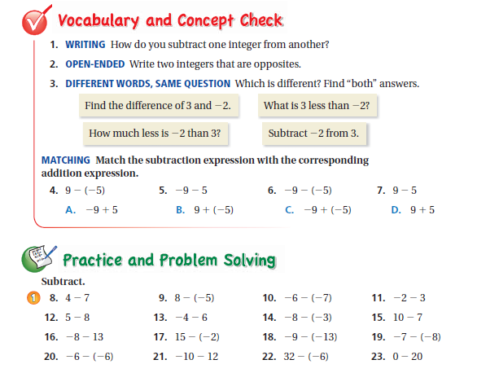
Directions: Write your answers in the spaces below.

 |  | 3.
4. | 5. | 6.
7. | 8. | 9.
10 | 11. | 12.
13. | 14. | 15.
16. | 17. | 18.
19. | 20. | 21.
22. | 23.

