Name:________________________ Date:_________

Ms. Napolitano **Activity 2.2** Activity #:__2.2____

**Topic**: Review of Module 2

**EQ**: How can you find and use the greatest common factor or the least common multiple of two whole numbers?

**I can** find and use the greatest common factor (GCF) or the least common multiple (LCM) of two whole numbers.

**CCSS**: 6.NS.4

**Activator: (UCLA &MIT)**

1. Tell if each number is **prime** (P) or **composite** (C) or **neither** (N).
2. 15
3. 1
4. 33
5. 19
6. Write the prime factorization of 72 in exponential form.

Answer:_________________________

1. Re-write each sum as a product of the GCF of the addends and another number.

15 + 45 = ________________

***Show your work below.***

1. What is the GCF of 9 and 12?
2. What is the LCM of 9 and 12?
3. Is the LCM and GCF of 9 and 12 different or the same? ***Justify your answer.*** ________________________________________________________________________________________________________________________________________________________________________________________________________________________________________________________________________________________________________________________

**Think-Pair-Share**

|  |  |  |
| --- | --- | --- |
| **Question #** | **Multiple Choice Question** | **Show all of your work.** |
|  |  |  |
|  |  |  |
|  |  |  |
|  |  |  |
|  |  |  |
|  |  |  |

Name:________________________ Date:_________

Ms. Napolitano **Activity 2.2 (Day 2)** Activity #:__2.2____

**Topic**: Review of Module 2

**EQ**: How can you find and use the greatest common factor or the least common multiple of two whole numbers?

**I can** find and use the greatest common factor (GCF) or the least common multiple (LCM) of two whole numbers.

**CCSS**: 6.NS.4

**real world Applications**

**Procedures *Group Work:***

1. Each pair will be assigned to one of the following questions below.
2. Read over the question independently.
3. Begin discussing your assigned question with your partner.
4. Answer all of the questions on the following page.
5. Be prepared to present your question with the entire class.

|  |  |
| --- | --- |
| **Questions** | **Work Shown.** |
| 1. Mika wants to create snack bags for a trip she is going on. She has 28 granola bars, 42 pieces of dried fruit, and 56 pretzels. If the snack bags should be identical without any food left over, what is the greatest number of snack bags Mika can make? |  |
| 1. Justin goes to the grocery store every 8 days, visits the gym every 11 days, and gets his car washed every 36 days. If he did both errands today, how many days will pass before he does both on the same day again? |  |
| 1. Gregorio is planting 15 bushes, 6 trees, and 48 flowers in rows. If he wants all the rows to be exactly the same, with no plants left over, what is the greatest number of rows Gregorio can plant? |  |
| 1. The amusement park is celebrating their anniversary by giving out gifts to visitors as they enter. They have come up with the following plan:   Free Gifts   |  |  | | --- | --- | | **Items** | **Free Gift** | | Hat | Every 2nd visitor | | T-shirt | Every 7th visitor | | Backpack | Every 10th visitor |   C:\Documents and Settings\ckeese\Local Settings\Temporary Internet Files\Content.IE5\NDGI8AVB\MC900044903[1].wmf      **C:\Documents and Settings\ckeese\Local Settings\Temporary Internet Files\Content.IE5\70C3ZT1K\MC900235383[1].wmfC:\Documents and Settings\ckeese\Local Settings\Temporary Internet Files\Content.IE5\XV0IDX1R\MC900325218[1].wmf**What visitor will be the first to receive a hat, t-shirt, and backpack? |  |
| 1. vote clip art.jpgU.S. senators are elected for six-year terms, and U.S. presidents are elected for four-year terms. One of the Senate seats in the state of Massachusetts was up for election in 2008, the same year President Obama was elected. What is the next year the same Senate seat will be up for election and a presidential election will take place? |  |

***Independent Practice:***

1. Televisions are delivered to Anchor TV every 5 days. DVD players are delivered every 7 days. Both televisions and DVD players are delivered on Monday of this week. In how many days will both televisions and DVD players be delivered on the same day?

**Part A**: Show your work.

**Part B**: State your solution below.

________________________________________

1. Pencils come in packages of 10. Erasers come in packages of 12. Phillip wants to purchase the smallest number of pencils and erasers so that he will have exactly 1 eraser per pencil. How many packages of pencils and erasers should Phillip buy?

**Solution:______________________________________________________________________**

1. Boxes that are 12 inches tall are being stacked next to boxes that are 18 inches tall. What is the shortest height at which the two stacks will be the same height?

**Solution:______________________________________________________________________**

1. At a display booth at the circus, every visitor gets a gift bag. Some of the bags have items in them as shown in this table.

**Items in the Gift Bags**

|  |  |
| --- | --- |
| **Items** | **Bags** |
| Cotton Candy | Every 3nd visitor |
| Popcorn | Every 5th visitor |
| Stuffed Animal | Every 10th visitor |

How often will a bag contain all three items?

**Solution:______________________________________________________________________**

1. Francois, Josue, and Franklin are running laps at recess. Francois takes 2 minutes to run a lap, Josue takes 3 minutes to run a lap, and Franklin takes 4 minutes to run a lap. How many minutes before they are all at the starting point again? How many laps will each boy have run?

**Solution:______________________________________________________________________**

1. Melanie and Anthony are setting up for a party. They bought plates in packages of 9 and forks in packages of 8. How many packages do they need to buy to get equal numbers of plates and forks?

**Solution:______________________________________________________________________**

1. Find the LCM of 3, 6, and 9

**The LCM is ____________.**

|  |  |
| --- | --- |
|  |  |

Name:________________________ Date:_________

Ms. Napolitano **Activity 2.2 (Day 2)** Activity #:__2.2____

**Topic**: Review of Module 2

**EQ**: How can you find and use the greatest common factor or the least common multiple of two whole numbers?

**I can** find and use the greatest common factor (GCF) or the least common multiple (LCM) of two whole numbers.

**CCSS**: 6.NS.4

**Extra Practice**

**UCLA**

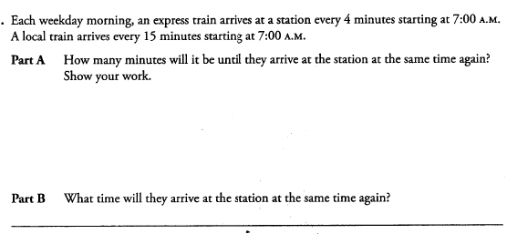

Name:________________________ Date:_________

Ms. Napolitano **Activity 2.2 (Day 2)** **CCSS**: 6.NS.4

**Topic**: Review of Module 2

**I can** find and use the greatest common factor (GCF) or the least common multiple (LCM) of two whole numbers.

Exit Ticket

1. Allison and her friends made dinner reservations at two local restaurants on two different days. While the first restaurant sat all the friends in groups of 8, the second restaurant sat all the friends in groups of 5. What is the smallest number of people that could be in the group?

2. Jelsa is making fruit baskets. She has 18 apples and 12 oranges. Jelsa wants to make all the fruit baskets identical without having any pieces of fruit left over. What is the greatest number of fruit baskets Jelsa can make?

Name:________________________ Date:_________

Ms. Napolitano **Activity 2.2 (Day 2)** **CCSS**: 6.NS.4

**Topic**: Review of Module 2

**I can** find and use the greatest common factor (GCF) or the least common multiple (LCM) of two whole numbers.

Exit Ticket

1. Allison and her friends made dinner reservations at two local restaurants on two different days. While the first restaurant sat all the friends in groups of 8, the second restaurant sat all the friends in groups of 5. What is the smallest number of people that could be in the group?

2. Jelsa is making fruit baskets. She has 18 apples and 12 oranges. Jelsa wants to make all the fruit baskets identical without having any pieces of fruit left over. What is the greatest number of fruit baskets Jelsa can make?

Name:________________________ Date:_________

Ms. Napolitano **Activity 2.2 (Day 2)** **CCSS**: 6.NS.4

**Topic**: Review of Module 2

**I can** find and use the greatest common factor (GCF) or the least common multiple (LCM) of two whole numbers.

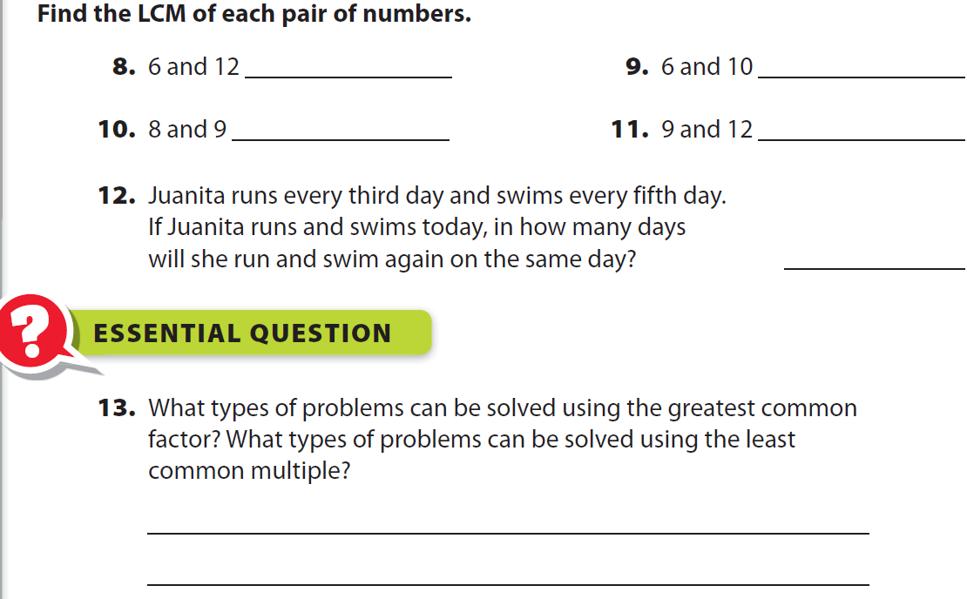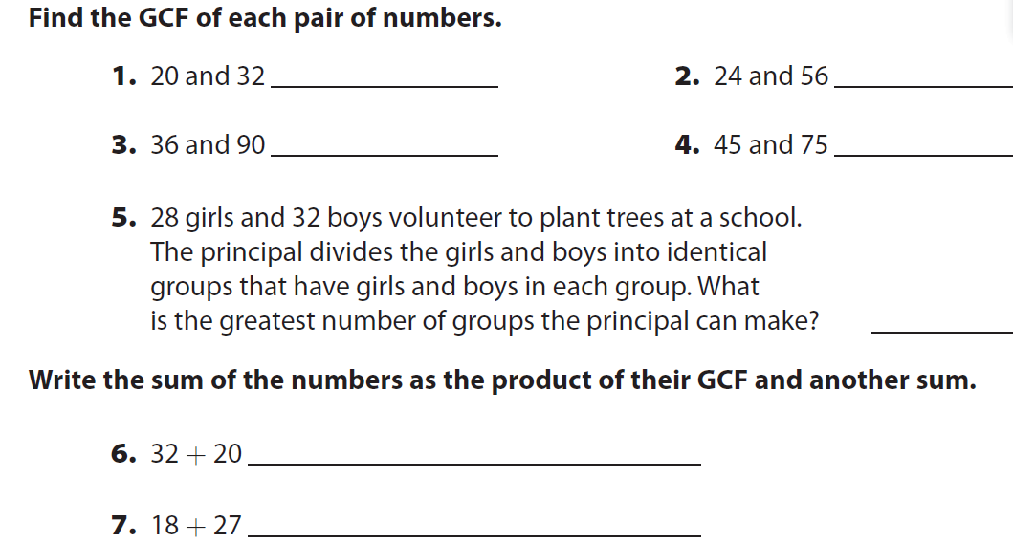**Homework**