Riverton Street Charter School June 2020

Social Studies Summer Challenge - Rising 6th Grade
Congratulations! You are officially an incoming 6th Grader

The emphasis in Social Studies – Global Perspectives is on the Eastern Hemisphere. You will learn about the people, places and events that have made up history in this part of the world and their effects on us today. The activities in this package will give you a head start on some of the skills and content you will learn. You are required to complete Activity 1 and one other activity of your choice for submission upon your return to school. However, doing all will be to your advantage. Successful completion of your requirement will be counted as a project grade. Please put lots of thoughts and effort into these activities, as they are the first impression you will make entering the new school year.
Activity 1: Make a timeline of your life. Start with important events in the past, followed by presently now, and then how these will lead to your future goals. Use the model below as a guide.
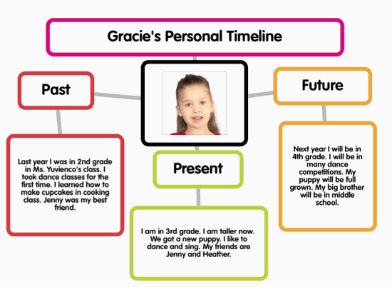
Activity 2: Think about three pieces of technology that have changed during your lifetime. Write three “then … but now …” sentences. Example: “Then, when I was little cell phones were just phones but now cell phones are like computers”
Activity 3: People who study the past (called historians) look at old things left behind to find out about the people who lived a long time ago. Take a look under a bed, behind a door, in the bottom of a closet, or under a couch cushion. List two things you find and what those things might tell some hundreds of years in the future about the people who lived there in 2019. Example: I found a soda bottle cap with writing inside. That tells me that the people who lived there drank soda and maybe revealed the information in the bottle cap to win a prize.
Activity 4: How well do you know the countries of the Eastern Hemisphere and their capitals? Test your knowledge at http://www.sheppardsoftware.com/World_Continents.htm. See if you can master at least level 2. Write down as many countries and their capitals as you can remember and then write the name of a country you would like to visit and why. (3-4 sentences)
Activity 5: Learn about the one of the most famous archeological sites – Catal Hoyuk, in modern-day Turkey. Explore the Mysteries of Catal Hoyuk at http://www.smm.org/catal/ and spend a few minutes checking out the “mysteries”, “activities”, or “artifacts” on that site. Write down 3-4 sentences to say how the game went and what you learned.
Activity 6: Be a Roman Emperor! Check out the game where you get to be a Roman Emperor and rule the Empire! (PS – an empire is a nation that is made up of a bunch of different kinds of peoples.) Write down what you did and how it went for you. http://www.pbs.org/empires/romans/special/emperor_game.html

If you have any questions or concerns, please contact me at 89.gvictor@nhaschools.com

Have a safe and enjoyable summer!!

