

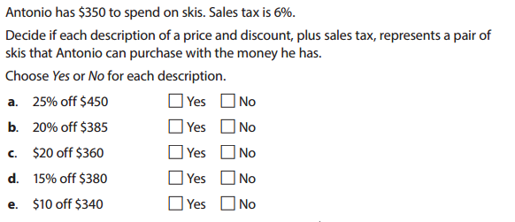

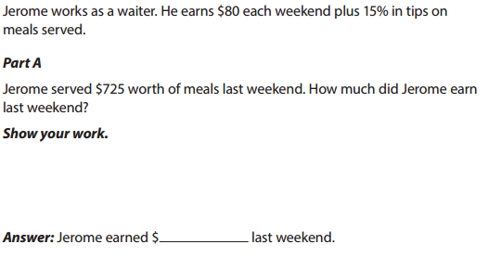

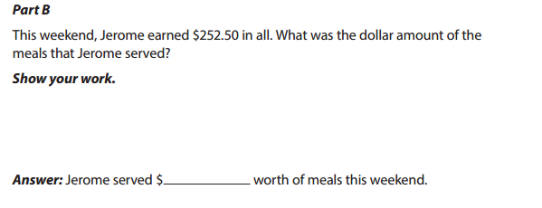

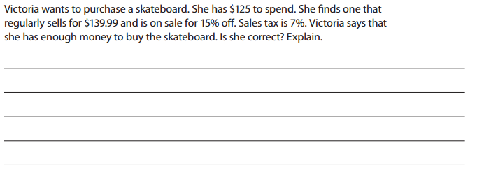

A fire department spend $900 to purchase new helmets and gloves. This price included a 6% sales tax. What was the price before the sales tax?

1. $846
2. $849
3. $854
4. $894