RSCS Name:____________________

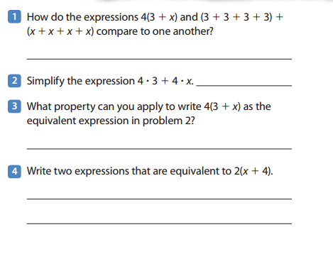7th Grade Thanksgiving Assignment Date:_________________

