Black-American Scientists & Inventors Research Project
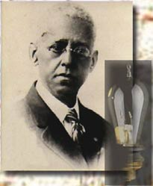
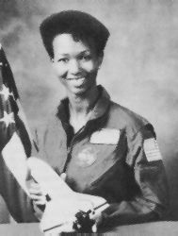
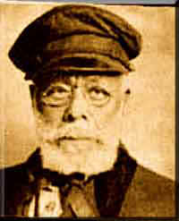
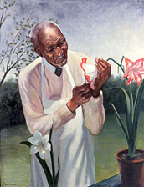

Black History Month is a celebration of the achievements by Black Americans and a time for recognizing their role in American History. You are a researcher on the History Channel and you have been assigned a notable black inventor/scientist that will be featured in an upcoming show. You need to find out the following information on your inventor/scientist so that the development team can turn it into a television show:

- When did they live?
- Where was this person born and where did he/she do his/her work?
- What did they invent or what was their most important accomplishment? (Be sure to explain the major contributions in detail)
- During which time period in history did this person live? How did the time and place affect him/her?
- What inspired them to do what they did?
- What obstacles did they have to overcome?
- A fact that you found interesting OR a quote by that person.
- How have our lives changed as a result of their accomplishment/invention?

In addition, create a cover for the paper that includes:
- Picture - We need to know what he/she looks/looked like!
- First, Middle and Last name (if all apply) of your scientist
- Birth date and Year of Death (if not alive)
- Where was this person born?
- Invention or contribution made by this person
- Your name, class and due date on the bottom right corner

Formatting

Typed document:
The document should be double spaced and the font should be Times New Roman, size 12pt.

PowerPoint presentation:
You have the option of creating a PowerPoint presentation instead of a paper but you are still required to have all of the required information for this assignment, including a title page for your presentation.

Websites to Use for Research (You are not limited to these sites)

https://webfiles.uci.edu/mcbrown/display/faces.html
www.blackinventor.com
www.biography.com

Wikipedia is NOT a reliable source for this assignment

Black-American Scientists & Inventors Research Project

You will draw the name of a scientist from a selection of about thirty scientists that I have selected for this project. You will be given more than enough time to work on your project. One week will be plenty of time if you use your time wisely. Have fun and learn enough about your scientist to share his/her contributions with the class. This project will count as a 100 point test grade.

Requirements:

A cover page with all required information. | 15 points
First, Middle and Last name (if all apply) of your scientist. | 5 points
Birth date and year of death, if not alive. | 5 points
In what country was this person born and where did he/she do his/her work? | 10 points
For what reason is this person famous? 5-8 sentences, in your own words, for credit.  (Include how time and place affected him/her, what inspired them and obstacles they had to overcome) | 20 points
Inventions or contributions made by this person. (Make sure to explain the major contributions in detail and include how our lives have changed as a result of their accomplishment/invention) | 15 points
Find an inspiring quote or any quote you’re interested in that the person stated. | 10 points
Presenting your findings with the class. | 10 points
Citing your references | 10 points

Please cut off and return to school

African-American Scientists & Inventors Research Project Acknowledgment
You will draw the name of a scientist from a selection of about thirty scientists that I have selected for this project. You will be given a week to work on your project. This should be plenty of time so please use your time wisely.

I am doing my research project on ___________________________________________________________.

I understand that I should do my best on the project since it will count as a 100 point test grade.

The due date is Wednesday, February 1, 2017. I understand that late projects WILL NOT BE ACCEPTED.

Signature of student __________________________________________________

Signature of parent/guardian __________________________________________________

