Name: Date: April 9, 2020
Document 4: Han Dynasty

During the Han Dynasty many great rulers ruled China and many things were invented that led to China becoming a great civilization. During the Han Dynasty, China was the most advanced civilization in the world. There were two memorable emperors in China during the Han Dynasty: Liu Bang and Han Wudi. Liu Bang was the first emperor of the Han Dynasty and was the first peasant to become emperor. Under his rule there was a stable government based upon the civil service system of Confucius. The Han Empire reached its peak under Han Wudi. He was a warrior emperor and ruled for 50 years. After he died, the Han Dynasty fell apart.
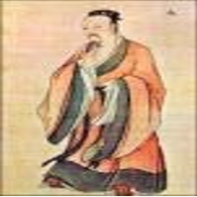Han Wudi
1. What happened after the death of Han Wudi? (1)

2. Why was Chinese Civilization more advanced than all the other civilizations under the Han Dynasty? (2)

3. Who do you think were the better rulers; Chinese emperors or Egyptian pharaohs? Why? (2)

Name: Date: April 10, 2020
Document 5: The Silk Road
The Silk Road was a trade route that ran for more than 4,000 miles across Asia. It started with only silk being traded from China, but other goods came into it. Goods were passed from trader to trader, getting more expensive as they went along. By the time the goods reached the last trader, they were very expensive. Not only goods traveled on the Silk Road though. Ideas traveled too which helped develop new discoveries.

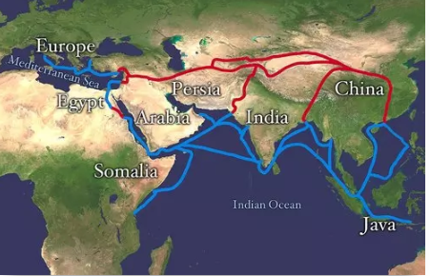
The Silk Road
1.What items traveled along the Silk Road? (1)

2 Describe how people traded on the Silk Road. (2)

3 What were some benefits of the Silk Road? (2)

Name: April 13, 2020
Ancient China – Document Based Question (DBQ) Essay
Historical Context:
For thousands of years, East Asian people were isolated from the rest of the world—this allowed them to develop their culture in a very unique way. China was home to one of the four early civilizations found around the world. However, China is different from the other civilizations. The culture that developed in Ancient China became the nation of China that exists today. Of course, there have been changes along the way, but the same culture has continued. The other three civilizations have faded away or been completely overtaken by new people. For this reason, historians say China is the oldest continuous civilization in the world.
TASK: Describe how the characteristics of Ancient China’s culture led to the success of the civilization. What were the effects of these contributions on the development of this ancient civilization?
Using the answers to the documents you studied (Documents 1 to 5) and your knowledge of the Ancient Chinese culture, write a well-organized essay.
In your essay remember to:
• Include an introduction, two(2) body paragraphs, and a conclusion
(4 paragraphs)
• Discuss the contributions that are described in the documents
• Show how these contributions lead to success
• Include details, specific examples, and explanations using the documents and outside information - for example, according to Document 5…, as stated in Document 2 …, as shown on the map of the Silk Road ….
• Grammar and spelling will count accordingly
Total points for essay (6)

Type your essay below

Due Date: April 15, 2020

