Ancient Rome

Activity #1: The Pantheon v. The Jefferson Memorial

How has Rome influenced the modern world?
Directions: Examine the image below and then complete the Image Analysis Graphic Organizer.
Part A: The Romans are known for their specific style of architecture which included the use of columns, arches, and domes. This architecture continues to influence buildings today. By using the Pantheon, considered the best-preserved building from the Roman Empire, we are going to see if we can determine how it influenced modern day architecture
The Pantheon
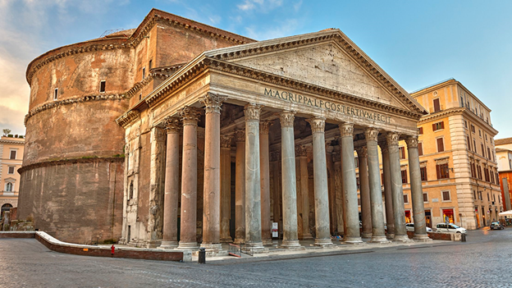
While no one knows exactly what this building was originally used for, the name Pantheon means “all gods.” Therefore, historians believe it was used as either a temple or as a meeting place for the Caesar (Emperor) who was often seen as a god.

Image Analysis Graphic Organizer
Identify | Interpret | Inquire
Identify three things you see in the image. | What do you think those three things mean? | What questions do you still have about the image?
1.
2.
3.

Examine the Jefferson memorial and find connections to the Pantheon.
Jefferson Memorial
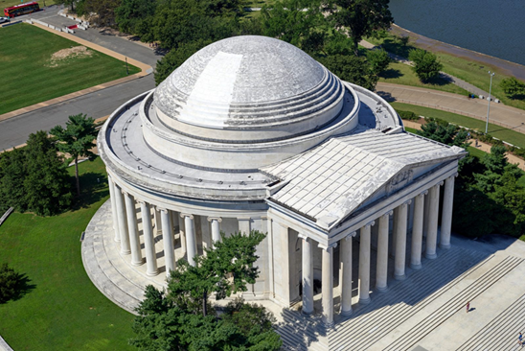

- What similarities do you see between the Jefferson Memorial and the Pantheon?

- Why do you think the Jefferson Memorial was designed to look like the Pantheon?

Part B: After completing these activities, consider what you have learned. Answer the inquiry question below. You will have an opportunity to answer this question again as we learn more about Ancient Rome.
How has Rome influenced the modern world?

