RSCS Name:________________________
Cal Tech TG Assignment Date:____________________
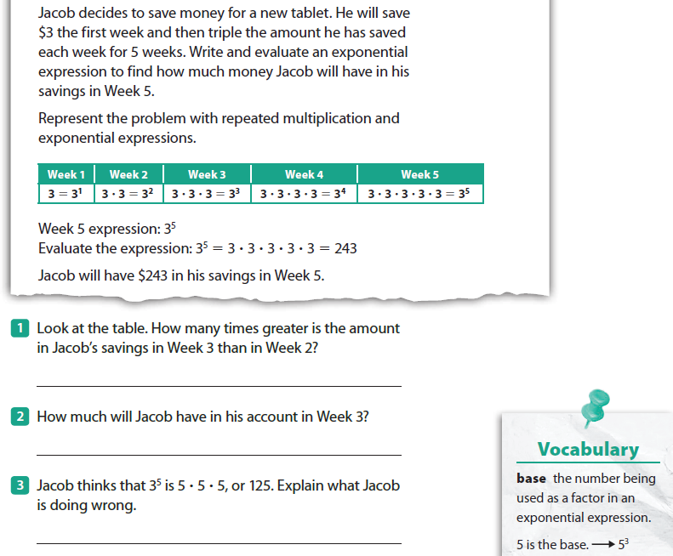
1)

2) Without evaluating the expressions, tell which is greater, $\left(3^{5}\right)\left(4^{5}\right) or (6^{4})×(2^{4})$
Explain:________________________________________________________________________
______________________________________________________________________________

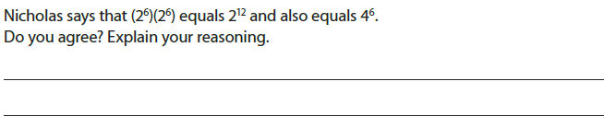
3)

The Zero and Negative Exponent
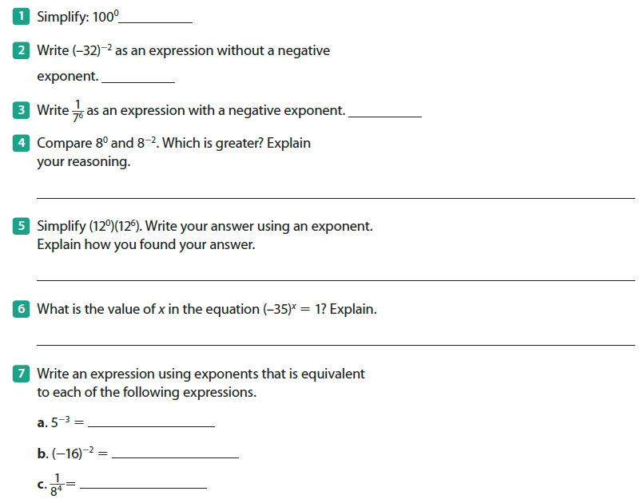
8)

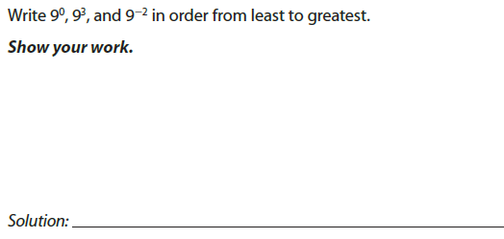
9)

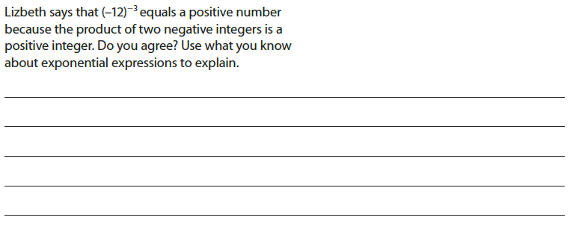
10)

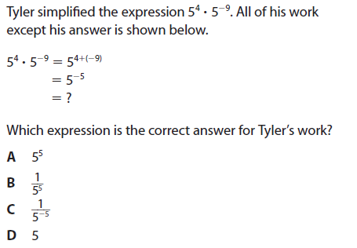
11)

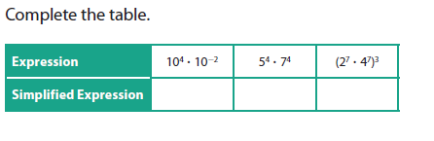
12)

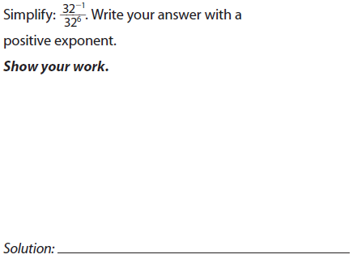
13)

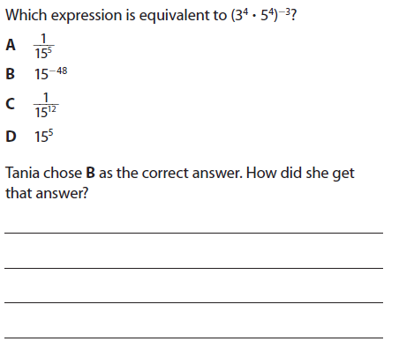
14)

