Name ___________________________________________________ Date _________________
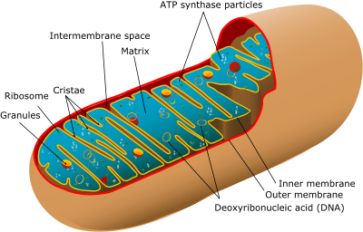
Living Environment: Cellular Respiration
Cellular Respiration
- Takes place in the _______________________.
- The mitochondria is known as the “_______________________” of the cell because it produces the energy needed for cellular functions.
Cellular Respiration
- There are ________________________ of cellular respiration.
- __________________________________________________.
- __________________________________________________.
- Aerobic and anaerobic respiration differs in terms of the amount of energy that is produced.
Aerobic Respiration
- ____________________________ is always required.
- The molecules of food (______________)are broken down to obtain ______________in the form of adenasine triphosphate (_________).
- Carbon dioxide and water are also bi-products.
Aerobic Respiration

Aerobic Respiration
- A lot of energy is produced during aerobic respiration, which may be as high as _______
___________________________________________________.
- This means that during aerobic respiration only one molecule of glucose will produce about thirty-eight energy units.
Anaerobic Respiration
- In plain language, ________________________ means where there is ____________ and thus anaerobic respiration is a term used for the respiration that occurs _________________________________________.
- Anaerobic respiration produces less energy when compared with the process of aerobic respiration.
- This can be best illustrated with the fact that during the anaerobic respiration ________ _______________________________ are yielded for one glucose molecule
Anaerobic Respiration
- Another name for anaerobic respiration is _________________________________.
- _________________________ is a byproduct of anaerobic respiration.
Anaerobic Respiration

Anaerobic Respiration
- Generally anaerobic respiration is always used by the ___________________________, which live in places where oxygen is missing, like muddy bottom of a river.
- In such places, the organism survives without depending to a large extent on oxygen. These habitats are known as ___________________.
Anaerobic Respiration
- What is lactic acid and why does it build up in our muscles?
- Follow the directions on your worksheet to learn more about anaerobic respiration and lactic acid.

