RSCS Name:____________________________
Class:__________________________ Date:_________________________
COMPARING LINEAR FUNCTIONS DAY 2
TRY NOW:
1) The table represents linear function G
INPUT | OUTPUT
-3 | 6
-1 | 10
1 | 14
3 | 18

Function L is when the output is six less than three times the input
Which statement is true?
a) Function G has a greater rate of change
b) Function L has a greater initial value
c) Function L has a greater rate of change
d) Function G has a smaller initial value

2) What is the solution, if any, to the following equation

$$\frac{2}{3}\left(9x-12\right)=\frac{1}{2}(12x+8)$$

3)

I DO:
Jack and Jill are both running in a 200 meter race. They are both running at a constant speed. Jacks running is represented by the equation y = 1.75x and Jill is represented by the table
Seconds | Meters
10 | 15
13 | 19.5
15 | 22.5
18 | 27

Based on the results, what is the difference between Jacks total race time and Jills total race time?
1) Jacks total race time

2) Jills total race time

3) difference between the two

4) Jeffrey and Claire are walking. Jeffery’s distance walked over time is represented by the graph. Claire walked 140 meters in 2 minutes. What is the difference between Jeffrey and Claire’s rate of change?
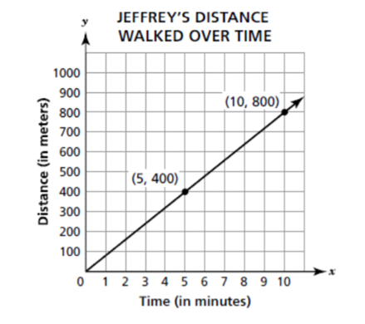

CFU-
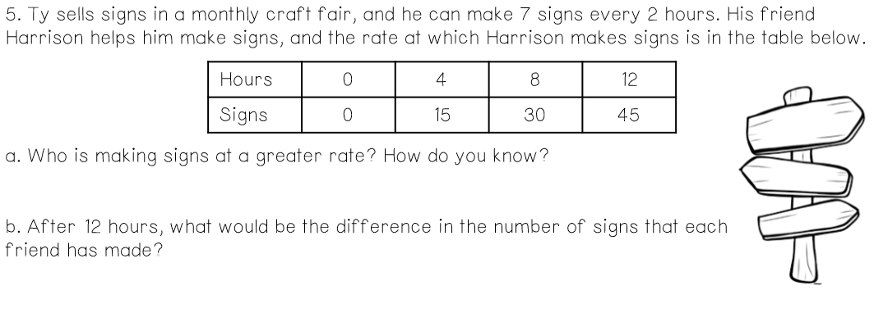

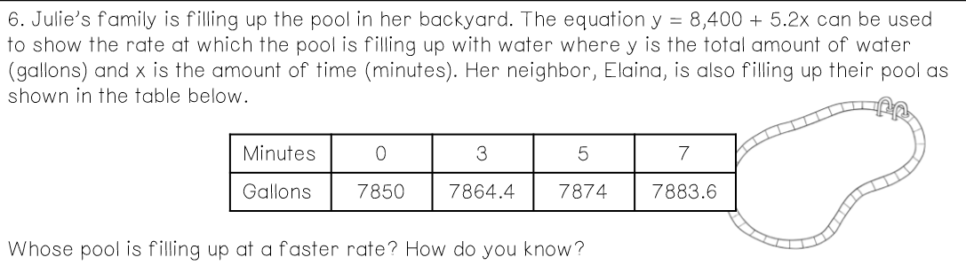

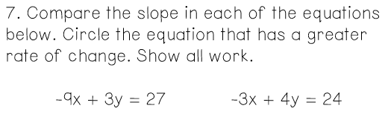

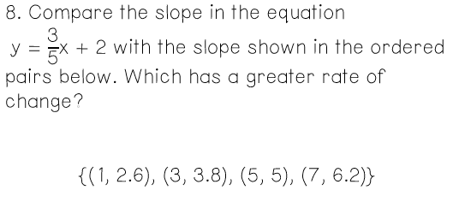

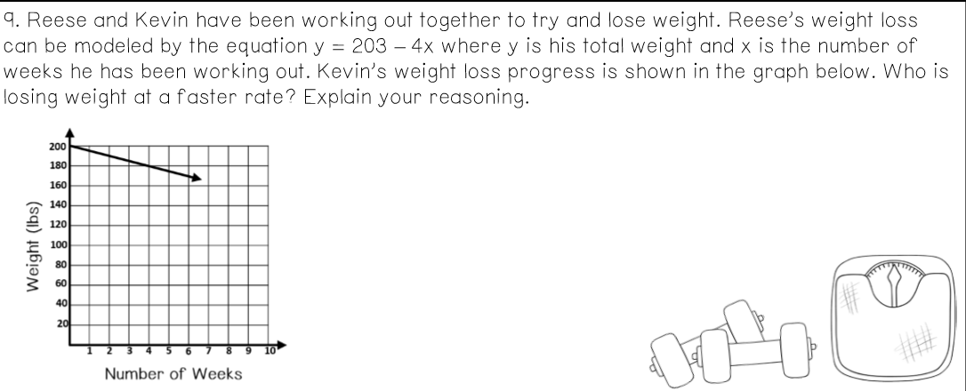

_________________________ has a greater rate of change because ____________________________________
___________________________________________________________________________________________

What do the initial values represent in terms of the context of the problem?

What do the rates of change represent in terms of the context of the problem?

