Name ___________________________________ Class __________________ Date __________
Living Environment: Diffusion, Osmosis, and Movement Across a Membrane – Part One

Diffusion

- Diffusion is - the __________________________________________________________

_______________________________________________________________________.

Diffusion

- When an area of high concentration of molecules exists near an area of low

concentration of these molecules, there is said to be a ___________________________.

- The diffusion of these molecules down the concentration gradient _________________
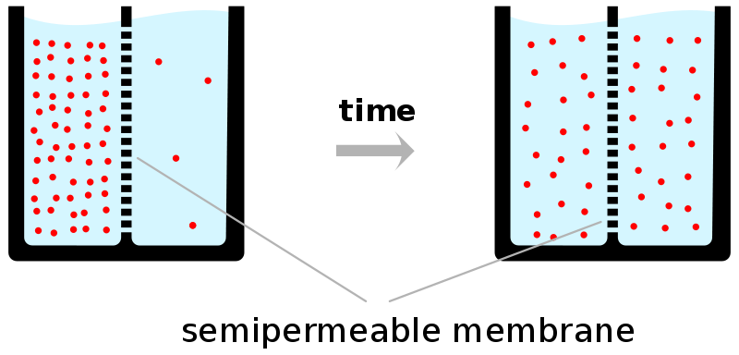
_______________ (exergonic or passive)

Diffusion

- Net diffusion stops when concentration on both sides equal (if crossing a membrane) or when there is a uniform distribution of particles.

- _____________________ is reached.

- Molecules continue to move, but ______________________________________ occurs (hence the phase "net diffusion" above).

- Diffusion of one compound is independent to diffusion of other compounds.

Diffusion

- A good example of diffusion is food coloring.

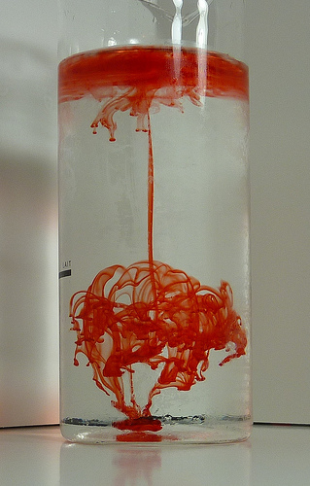
- If you place a drop of red food coloring in a beaker of water eventually the entire beaker of water will have a red tint.

Diffusion

- Other everyday examples of diffusion are:

- Sugar will diffuse through tea until the entire cup of tea is sweet. (We stir the tea to speed up the diffusion.)

- The odor of food cooking diffuses throughout the kitchen. If you open the
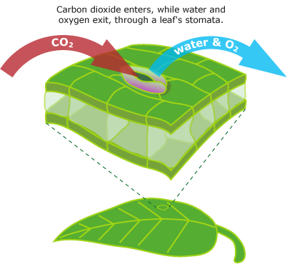
kitchen door it will spread into the next room.

Diffusion

- Examples of diffusion in science are:

- _____________________________________________________.

- Oxygen diffusing out of the stomata and lenticels of leaves.

Factors Affecting Diffusion Across a Plasma Membrane

- Diffusion directly through lipid bilayer:

- The greater the lipid solubility of the diffusing particle, the more permeable the membrane will be.

- All else being equal,_______________________________________________________.

- ______________________________________________________ across lipid bilayer.

Osmosis, the Passive Transport of Water

- Osmosis is - _____________________________________________________________.

- __________________________________________, hence the term “passive transport.”
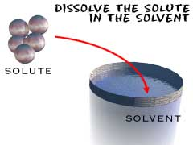
Osmosis

- Plasma membrane permeable to water but not to solute.

- Solute = _____________________________________.

- Solvent = ________________________________ in which particles may be dissolved.

Osmosis

- Water moves ____________________________________________________________

_______________________________________________________________________.

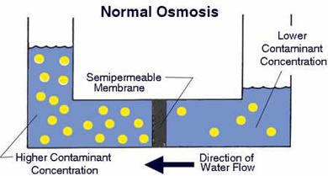
- In other words, if there is a low concentration of solute, then there is a high concentration of water molecules.

Osmosis

- If there is a high concentration of solute, then there is a low concentration of water.

- Just as with the diffusion of other molecules, water will move from an area of high

concentration of water molecules to an area of low concentration of water molecules,

“________________________________________________________.”

How Will Water Move Across Semi-Permeable Membrane?

- Solution A has 100 molecules of glucose per ml.

- Solution B has 100 molecules of fructose per ml.

- How will the water molecules move?

- How Will Water Move Across Semi-Permeable Membrane?

- There will be __________________________________________________ since the concentration of solute in each solution is equal.

- How Will Water Move Across Semi-Permeable Membrane?

- Solution A has 100 molecules of glucose per ml.

- Solution B has 75 molecules of fructose per ml.

- How will the water molecules move?

- How Will Water Move Across Semi-Permeable Membrane?

- _______________________________________________________________________

_______________________________________________________________________.

Solution Types Relative to Cell

- _____________________________________: Solute concentration higher outside the cell than inside the cell.
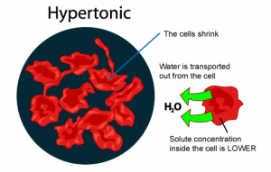
- Hyper = more (think hyperactive); Tonic = dissolved particles

- ________________________________________________.

- Cell shrinks

Solution Types Relative to Cell

- ______________________________________: Solute concentration lower outside the cell than inside the cell.

- Hypo = less, under (think hypodermic, hypothermia); Tonic = dissolved particles
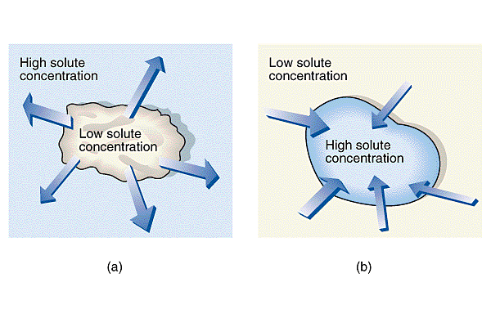
- ______________________________________________.

- Cell expands (and may burst)

Solution Types Relative to Cell

- _____________________________________: Solute concentration equal to that of cell.

- _____________________________________________________.
