Name ____________________________________ Period ___________ Date ______________
Living Environment: Diffusion-Part 2
Diffusion: Part 2
- Recall that diffusion is the movement of molecules from an area of __________________________ to an area of ___________________________ down a concentration gradient.
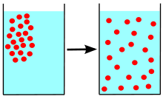
- Requires no energy and is sometimes called “______________________________.”
Diffusion: Part 2
- Also recall that _____________________________________________.
- Requires no energy
- Also passive transport.
Facilitated Diffusion
- _______________________________ is a process whereby a ____________________
______________________________________________________________________.
Facilitated Diffusion
- The facilitator is an _____________________________________________ that spans the width of the membrane.
- The force that drives the molecule from one side of the membrane to the other is the force of ______________________ .
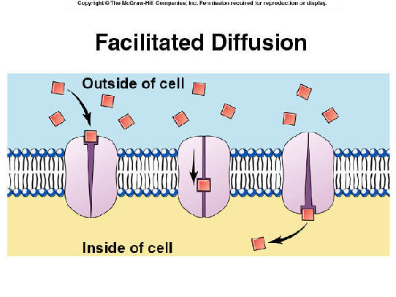

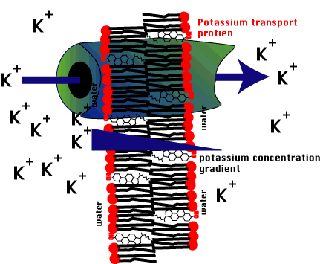
Facilitated Diffusion
- In the figure right, K+ ions are passing through
a membrane using a __________________________________________________.
- The ions are moving _____________________________________________ so the process is a diffusion of K+ ions.
Facilitated Diffusion
- Facilitated diffusion ____________________________________________________
____________________________________________________________________.
- If there is a higher concentration of a specific molecule outside the cell than inside, then facilitated diffusion will work to facilitate entry of that molecule into the cell until equilibrium is reached.
Facilitated Diffusion
- If there is a higher concentration of a specific molecule inside the cell than outside, then facilitated diffusion will work to facilitate movement of that molecule out of the cell until equilibrium is reached.
- Among other things, facilitated diffusion can be used to ________________________
______________________________________________________________________.
Facilitated Diffusion Animation (Quiz)
- Facilitated diffusion requires
A)enzymes.B)carrier proteins.C)lipid carriers.D)carbohydrate carriers.E)lipid or carbohydrate carriers.

- Facilitated diffusion occurs
A)into the cell only.
B)out of the cell only.
C)in either direction depending on the temperature.
D)in either direction depending on the concentration gradient of the molecule. E)in either direction depending on the size of the molecule.
- Facilitated diffusion is used to transport
A)sugars and amino acids.B)H₂O and O₂.C)CO₂ and O₂. D)CO₂ and H₂O.E)sugars and H₂O.
- Unlike simple diffusion, facilitated diffusion requires energy expenditure by the cell.
A)TrueB)False
- Facilitated diffusion requires a specific transporter for a specific molecule.A)TrueB)False
Active Transport
- When cells need to take in or remove substances against a concentration gradient they must use ________________________________.
- Active transport is ________________________________________________________
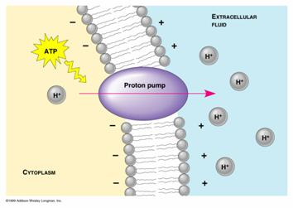
_______________________________________________________________________.

Active Transport
- When a cell expends ATP directly during active transport, the process is called _______________________________________________.
- Using another energy source, such as the potential energy stored in an ion gradient, is _______________________________________________.
Active Transport
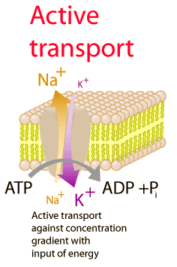
- ___________________________________________________________ is an example of an active transport mechanism.
Sodium-Potassium Pump Animation (Quiz)
- The sodium-potassium pump functions to pump
A)sodium ions out of the cell and potassium ions into the cell.
B)sodium ions into the cell and potassium ions out of the cell.
C)sodium and potassium ions into the cell.
D)sodium and potassium ions out of the cell.
E)sodium and potassium ions in both directions across the cell membrane.

- What is the source of energy used to power the sodium-potassium pump?A)breakdown of ATP B)formation of ATP
C)transport of ATP by the pump D)breakdown of GTP
E)transport of GTP by the pump
- During one cycle, the sodium-potassium pump binds and moves.
A)1 Na⁺ and 2 K⁺.B)2 Na⁺ and 2 K⁺.
C)2 Na⁺ and 3 K⁺.D)3 Na⁺ and 2 K⁺.
E)3 Na⁺ and 3 K⁺.
- The sodium-potassium pump is a trans-membrane protein.
A)TrueB)False
- The binding and release of sodium or potassium ions are due to conformational changes in the protein.
A)TrueB)False

