December 9, 2015
Dear Parents,
Please be advised that we will begin working on EDpuzzle.com again this year. As was the case last year, registration is free and simple, and the company has an app the scholars may access as well. I will begin assigning scholars Spanish homework on the website in addition to written homework they are responsible for submitting to me in person. Directions as to how to create an account are as directly below. If your child has their login information from last year, see the following page for instructions on linking their established account to the new class for this year.
To Create a New Account:
- Go to the website edpuzzle.com

- Click on in the center of the screen
- Fill in the required information, then click at the bottom of the pop-up window.
- Click in the upper right hand corner.
- Type in our class code: dLKPjb
- Ensure that you see 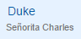 in the top left corner.

To Link Last Year’s Account to This Year’s Class:
- Go to the website edpuzzle.com
- Click in the upper right hand corner.
- Click 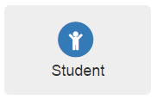 to the right.
- Type your username and password from last year.
- Click to the left.
- Enter Duke’s class code: “dLKPjb”. Then, press “Enter” on the Keyboard.
- You should see 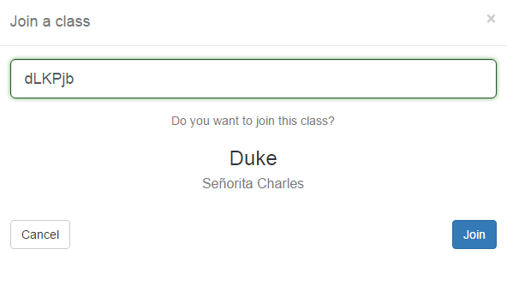
- Click
Thank you for your continued support,
Señorita Charles
Spanish Teacher, K-8
89.mcharles@nhaschools.com

