**Genetics, DNA and RNA! (Part 1)**

Name:_____________________________________________ Date:___________________

1. What IS genetics?
   1. Genetics is the study of how we _________________________ _________________________.
2. Terms to know!
   1. **Chromosome:** a long strand of _____________ that contains many ______________.
   2. **Gene:** a specific location on a ____________________________ that codes for a specific _______________. (Ex: ear pits, hairy knuckles, etc)
   3. **Allele:** different _____________________ of the same __________________. (Ex: have ear pits, don’t have ear pits)
   4. **Autosome:** a chromosome that controls all ________________________ traits.
   5. **Sex Chromosome:** the ______ and ______ chromosomes. They determine __________________ (boy or girl).
   6. **Dominant:** a version of an allele that is _____________________________ even if only ______________ gene is present. Represented by a _____________________________.
   7. **Recessive:** a version of an allele that is only _____________________________ if ______________ genes are recessive. Represented by a _________________________.
   8. **Genotype:** The _______________________ of __________________ a person has.
   9. **Phenotype:** The ___________________________ expression of a trait.
      1. **Ex:** having the dominant trait of non-red hair, or having the recessive trait of red hair.
   10. **Punnett Square:** used to determine the ____________________________ outcome of a cross between parents.
   11. **Gene-Chromosome Theory:** this is the idea that on the SAME _________________________ in every person, EVERY _______________ is in the same location.
3. **\*\*\*You have ________________ genes for every one _______________________.\*\*\***

We have ______ chromosomes, but we think about them as _______ pairs. For pair #11, you get one from _____________ and one from ______________. Each PAIR controls the same traits.

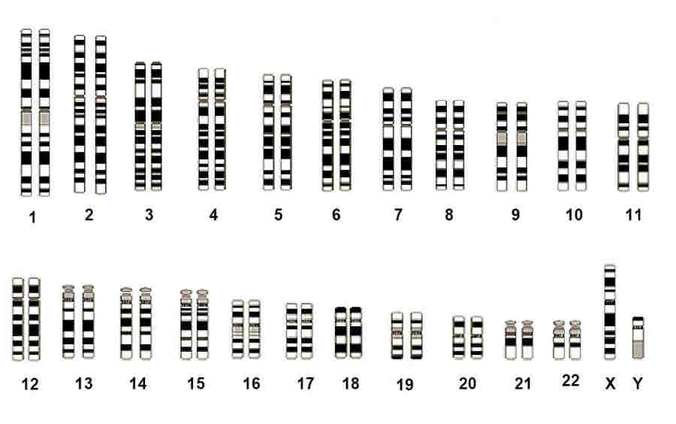

1. DNA Nitty Gritty!
   1. Functions of DNA
      1. Controls ALL ________________________ production.
      2. Controls all _____________________ traits (Mostly by making certain proteins! For example, brown hair protein is different than blonde hair proteins.)
      3. Controls some ____________________ traits?? Nature vs. Nurture?? This means, how much of your personality is controlled by your genes and how much is formed by your life experiences?? We know that both matter, but no one can really say how much each plays a role!



* 1. Monomer of DNA is a ____________________________.
     1. A nucleotide contains one ___________________, one _____________________________ and one _____________________________ base.
  2. Basic structure of DNA is called a __________________________________________.
  3. The “backbone” or sides are made of repeating ________________________ and _______________________________.
  4. The middle “rungs” (as in a ladder) are the nitrogenous _____________________. These are the important parts of DNA!! _______________________ always matches with ____________________________, and _________________________ always matches with _______________________________. A dumb sentence to help is “All Thieves Get Caught”.

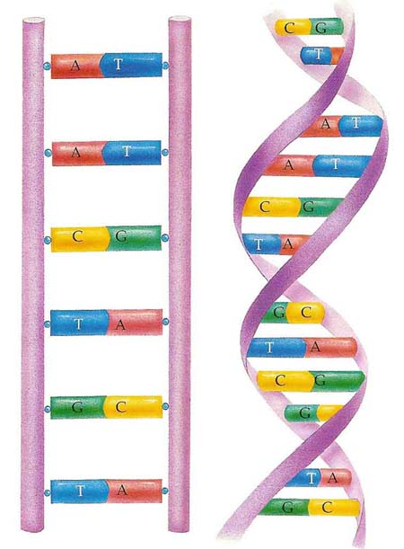

1. DNA Replication
   1. DNA replicates during ____________________________.
   2. First, the original strand of DNA _____________________________.
   3. Next, each open ________________________________ binds to a new complimentary ____________________. This means if there was a T (thymine) open, and nucleotide with A (adenine) will bind on.
   4. The end result is two __________________________ strands of DNA. Each new strand is _________________ of the original and half _______________.
2. Genetic Engineering
   1. ______________________ can be cut out of one organism and be ______________________ into another. This creates man-made combinations of traits!!
   2. One practical use is using bacteria to create insulin!
3. The _______________ for producing human insulin is ____________ from a human ________________________.
4. The __________ of a bacteria (called a plasmid) is cut and the human insulin ______________ is inserted.
5. The bacteria ___________________ and pass along the human insulin information.
6. The bacteria cells produce human insulin which is the ___________________ for human use!

