Geography and History Activity
Hellenistic Culture
Understanding Location: Hellenistic Cities
Soon after the death of Alexander the Great, his empire was divided into three kingdoms and then some 50 years later, a fourth kingdom. The rulers and wealthy citizens of these lands wanted to import Greek culture into their kingdoms. They built new cities and wanted to make them like Athens and other Greek cultural centers. They brought in Greek architects and sculptors to plan and build the new cities. The Hellenistic cities became great centers of learning, filled with large, beautiful buildings decorated with sculpture and art.
Location and Cities
Water was a critical factor as to where new cities were built and whether they thrived. Location on a sea made travel and trade easier. A supply of fresh water was essential for survival—for drinking, growing food, and cleaning.
The most important of the new cities was Alexandria, Egypt. It had two harbors on the Mediterranean Sea. Rainwater collection systems and a canal to the Nile River guaranteed a supply of fresh water. In addition, Alexandria’s museum and library attracted scholars from all over the Hellenistic world. The great lighthouse, known as the Pharos of Alexandria, was one of the Seven Wonders of the World.
Another city, Antioch, in what is now Turkey, was one of the new Hellenistic cities and the capital of the Seleucid Kingdom. The harbor of Antioch was at the mouth of the Orontes River. Antioch’s location at the western end of an overland trade route made it a busy city, visited by people from all over the Hellenistic world. Goods came from the East and were then shipped by sea to ports all around the Mediterranean. Like Alexandria, Antioch was an international and stylish city. Many Greeks migrated to this new city. The city, with its wide streets, had theaters, temples, a library, and public squares with statues of heroes, gods, and goddesses, much like Athens and other great cities of Greece. People from many different religions and cultures also moved to Antioch, and they thrived in the Hellenistic culture.
Pergamum was on a hill on the Caicus River 16 miles (25.7 km) from the Aegean Sea. Its buildings included a library that was second only to the one at Alexandria, a grand theater, and many temples. The rulers brought works of art from Greece to decorate the city, including an altar of Zeus that was a masterpiece of Hellenistic art. They also commissioned numerous works of sculpture, painting, and decoration from resident artists.
Trade, commerce, and the exchange of ideas and art were common among the Hellenistic cities. They were all connected by land or by sea (or both). Through the spread of Greek culture, they were connected culturally, too.

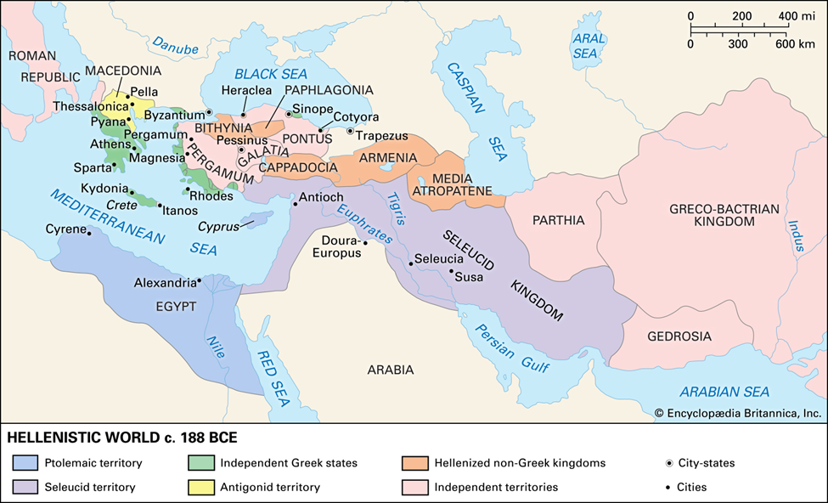

Architecture and Sculpture
Hellenistic architecture and sculpture were modeled on Classical Greek art but were more varied. Hellenistic style reflected the broader perspective of people who were connected to each other across large geographic areas. It also reflected the personality of Alexander the Great, who had given his men the idea that they were heroic and larger than life. They had conquered almost all of the known world and were understandably impressed with their accomplishments. The tendency in Hellenistic art was to exaggerate styles from Classical Greece. Many of the Hellenistic temples were huge. Theaters and stadiums were similarly gigantic. Even private homes became much more luxurious and palatial, or like palaces.
Sculpture showed bold, vigorous displays of emotion and action. The altar of Zeus at Pergamum, for instance, had a sculptured wall showing a battle of gods and giants. The muscular figures are superhuman and energetic and are shown in all the torment of their struggle. Many of the rulers and wealthy citizens who had been Alexander’s generals commissioned heroic portraits of themselves.
Filled with giant sculptures, temples, theaters, and stadiums, these cities were symbols of civilization in the Hellenistic world. Cities were places where Greek culture thrived. They were centers of art, literature, drama, and ideas. The lands that Alexander and his men had conquered were transformed by the influence of the Hellenistic culture they imported from Greece.
Understanding the Concept
1 Identifying What was the primary body of water used for travel and trade in the Hellenistic Era?

2 Explaining What were two geographic features of Alexandria that helped it become an important city?

3 Applying the Concept Analyzing How did Alexander’s personality influence the architecture and art of the Hellenistic Era?

4 Contrasting What made the Hellenistic style of art and architecture different from the Classical Greek style?

5 Making Generalizations The Hellenistic cities were all physically connected either by land or sea or both. What non-physical qualities connected them all to each other?

