Sound waves enter the outer ear. They travel down the ear canal and make the eardrum vibrate. (The eardrum is a thin skin that stretches across the inner end of the ear canal.) The vibrations of the eardrum cause vibrations in the three little bones in the inner ear. These little bones vibrate a spiral-shaped organ called the "cochlea." The cochlea is filled with liquid and tiny hairs. Each hair has its own connection with a nerve that goes to the auditory nerve. Auditory means hearing. The auditory nerve sends a signal to the brain.

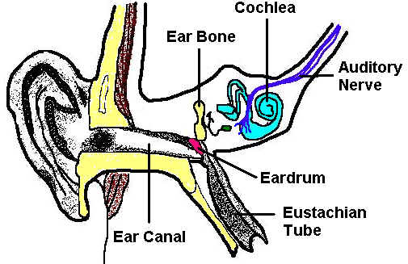
Directions: Answer the questions below about the ear and how it works.
- 2. As sound waves reach the ear they travel down the ear canal and make the vibrate.

- The eardrum is a thin skin that stretches across the inner end of the ear .

- What do sound waves cause the eardrum to do?
vibrate
stretch
hear

- What is located inside the cochlea?
liquid and tiny bones
liquid and tiny hairs

little bones are located in the inner ear.

- Auditory means .

- The auditory nerve sends messages to the
brain
eardrum

