Name: ______________________
I can explain how natural resources are cycled through our environment

“The lives of future generations depend on people’s use of natural resources today.”

Natural Resources – Materials supplied by
List 3 examples of natural resources that we depend on for our modern American lifestyle
1.
2.
3.

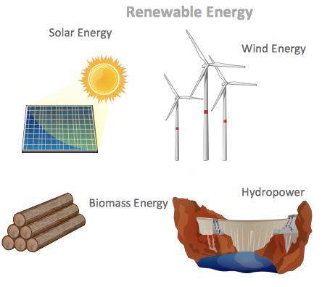
Types of Natural Resources

Renewable Resources
- Can be replaced/“ ” given sufficient time
- Examples: (Biomass)

Non-renewable Resources
- (limited) resource
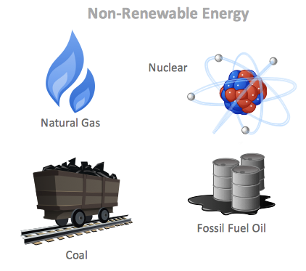
- Can be (used up)
- Examples:

Natural Resources: keep – maintain - - protect -

Remember the 3Rs:
- Reduce: Avoid using the resource

- Reuse: Use the same product over and over, instead of throwing it away after one use.

- Recycle: Put items in the recycling so that it can be used to make another product.

