Riverton Street Charter School
Social Studies
Name:
Date:

Atlas – World Map Political
Visual Skills- Analyzing Maps / Globes
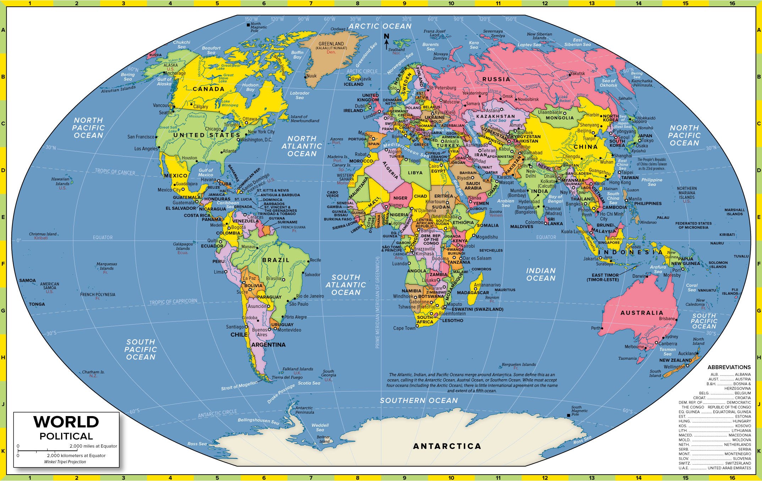
1 Which continents do the Equator pass through?
2 What are some countries that the Equator passes through?
3 Which continents does the Prime Meridian pass through?
4 What are some countries that the Prime Meridian pass through?
5 Which country takes its name from its location on either the Equator or Prime Meridian?

