Riverton Street Charter School
Social Studies April 16, 2021
Name:

Complete both Mapwork and Vocabulary.

1 Mapwork

Match the letters on the map with the numbered places listed below.

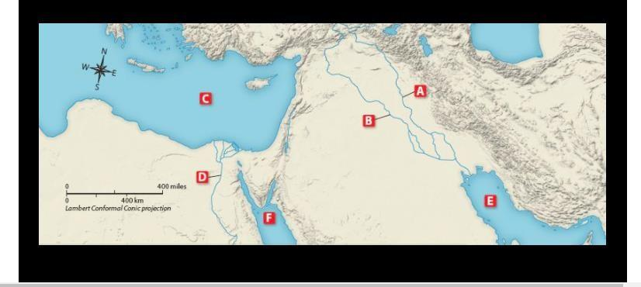

Answer Sheet

1. Nile River 2. Euphrates River
3. Mediterranean Sea 4. Tigris River
5. Persian Gulf 6. Red Sea

2 Vocabulary
Answer Sheet: Write the letters near each number.
1 7
2 8
3 9
4 10
5 11
6 12

