Photosynthesis Notes
Name:____________________________________________ Date:_________________ Set:________
- Intro Info
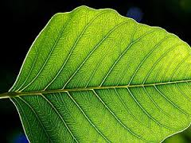
Producer (also known as: ____________________________) : An organism that makes its own __________________ from ______________________________________ and ______________________________________________.
Consumer (also known as: ____________________________) : An organism that gets its ___________________ from _______________________________ or other heterotrophs.
Nearly ___________ of the energy that powers _______________on Earth originally comes from the ______________.
- Photosynthesis General Stuff
Photosynthesis is the process to ___________________ (or MAKE) ___________________ (which is ORGANIC) from ___________, ___________________________ (both INORGANIC) and ___________________ energy.
**Even though Autotrophs make their own glucose, they still MUST undergo cellular respiration to convert glucose to ATP!**

- First…the Leaf, where all this fun happens!
1..
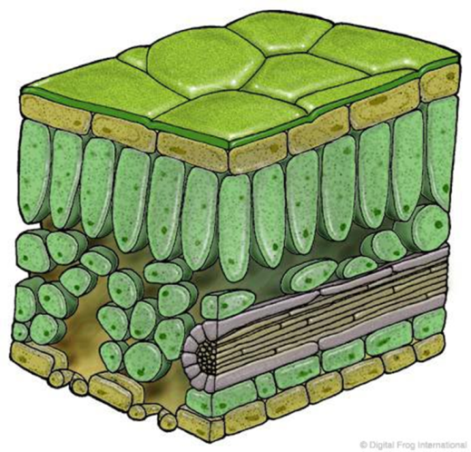
8
7
6
5.
4.
3.
2.
Why is the leaf green? The colors we see are _________________________ off of an object, all other colors are _______________________.

- Photosynthesis Nitty Gritty
______________ + ________________ ____________________ + ________
Now write out the word formula too!
___________________________________________________________________________
Where does this fun happen?
_______________________________ is the green pigment in plants that _____________________ light energy. It is found in _______________________________.
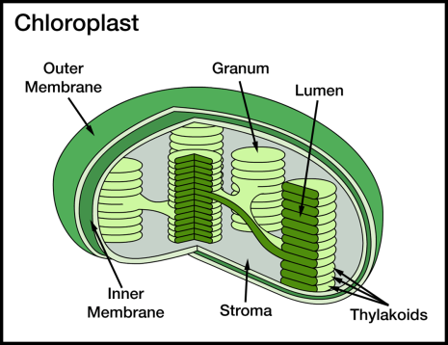
- Factors Affecting the Rate of Photosynthesis
There are THREE main things that impact the rate of photosynthesis.
- ________________________________________
- ________________________________________
- ________________________________________

