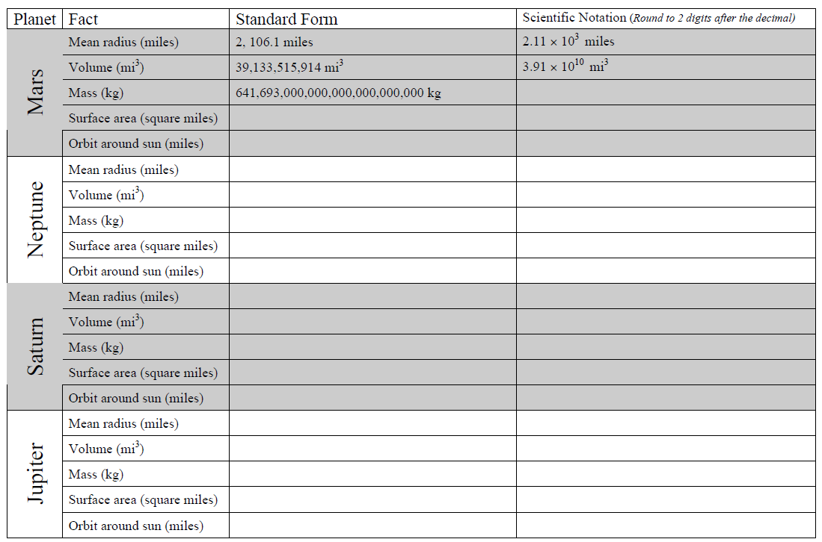
Next, you need to find out some information about other planets in our solar system. Using the worksheets printed from the NASA website, fill in the following chart. If you have a computer, Go to: http://solarsystem.nasa.gov/planets Click on the planets along the left side of the screen, and then click on the Facts and Figures tab.

