RSCS Name:___________________
Class:_____________________ Date:_________________

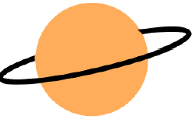
SCIENTIFIC NOTATION SPACE PROJECT

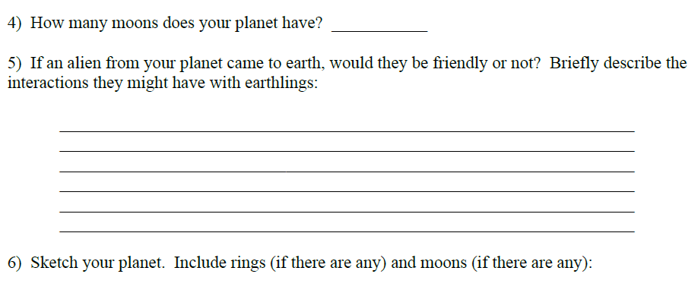
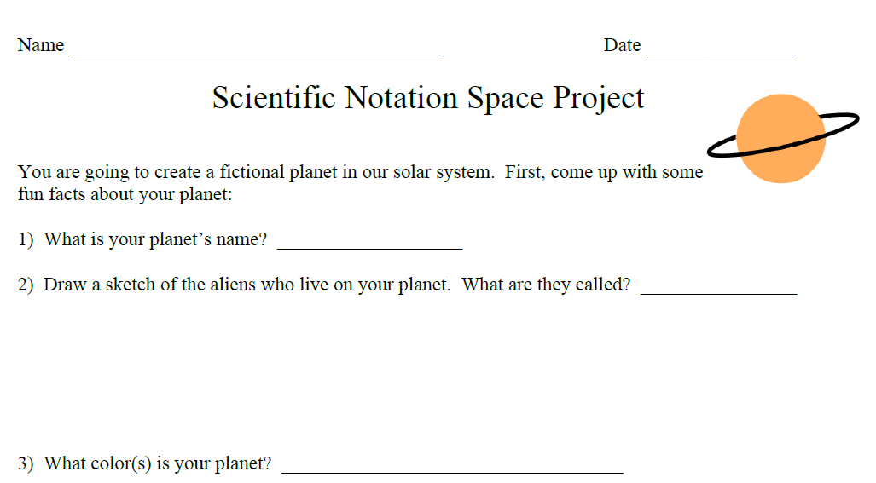

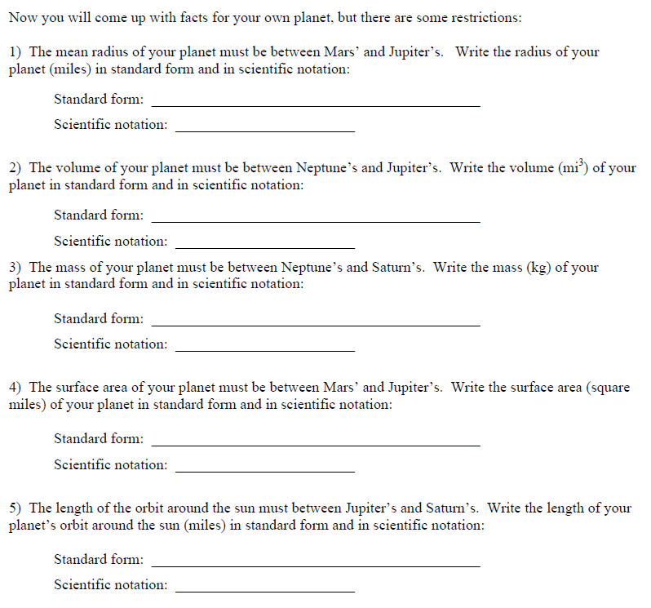

Now you are going to compare your planet to some of the other planets in our solar system (there is space provided under the
- The radius of my planet is _________ times the radius of Mars

- The volume of my planet is ___________ times the volume of Neptune

- The mass of my planet is __________ times the mass of Neptune

- The surface area of my planet is __________ times the surface area of Jupiter

- The length of the orbit around the sun of my planet is _____________ times the length of the orbit around the sun of Saturn
