RSCS Name:__________________________
Class:_____________________________ Date:_______________________
Johns Hopkins Homework
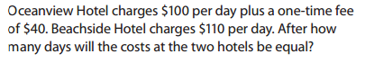
1)

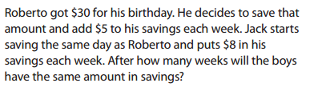
2)

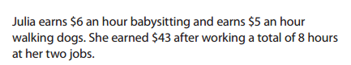
3)

How many hours at each job did she work?

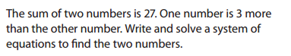
4)

