Date: April 22
Writing and Solving Equations

Read then answer the questions that follow.
Part G:
- On February 20, 2013 the Celtics played the Lakers in LA. Kevin Garnett had some points in the game. Let k represent the number of points Kevin Garnett made. Paul Pierce made 14 more points than Kevin Garnett.
  - Write an expression that shows how many points Paul Pierce made.

Expression: ___________________
  - Paul Pierce had 26 points in the game. Write an equation to show the number of points Kebin Garnett made in the game.

Equation: ___________________
  - How many points did Kevin Garnett make in the game?

Answer: ___________________
Part H:
- Eden, Isaiah, and Naoomi are performing a poem for class. The poem has a number of lines. Let n represent the number of lines in the poem. They each need to read the same number of lines of the poem.

  - Write an expression to show how many lines each person will need to read.
Expression: ___________________
  - Each person will need to read 17 lines. Write an equation showing what is going on. How many total lines are in the poem?

Answer: ___________________

Challenge:
- It costs $10 per month to go to Planet Fitness. Let m represent the number of months you go to Planet Fitness. When you sign up you have to pay a registration fee of $25.
  - Write an expression to show how much total money you’ll spend if you join Planet Fitness for m months.

Expression: ___________________
  - You end up spending a total of $105. Write an equation to show what is going on.
Equation: _____________________
  - How many months did you go to Planet Fitness?

Answer: ___________________
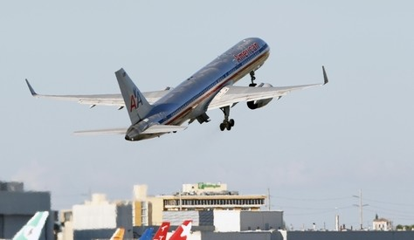
- Keayon flew on a plane to Miami. Let d represent the distance in miles from Boston to Miami. The flight took 4 hours. Keayon wants to figure out the speed the plane was going in miles per hour.
  - Write an expression to show the speed of the plane in miles per hour.
Expression: ___________________
  - The speed of the plane was 314.5 miles per hour. Write an equation showing what is going on.
Equation: _____________________
  - What is the distance in miles between Boston and Miami?

Answer: ___________________
- Mr. Wyrick is buying t-shirts for the PHA basketball team. Each shirt costs $5.50. Let p represent the number of players on the team.
  - Write an expression to show how much it would cost to buy all the players t-shirts.

Expression: ___________________

  - The total cost of t-shirts for the team is $77. Write an equation to show what is going on.

Equation: ___________________

  - How many students are on the team?

Answer: _____________

