RSCS Name:________________________________
Class:__________________________ Date:_____________________________
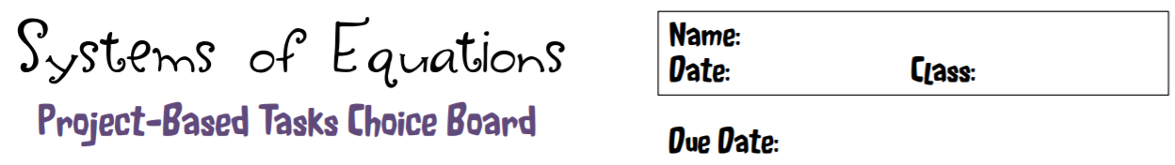
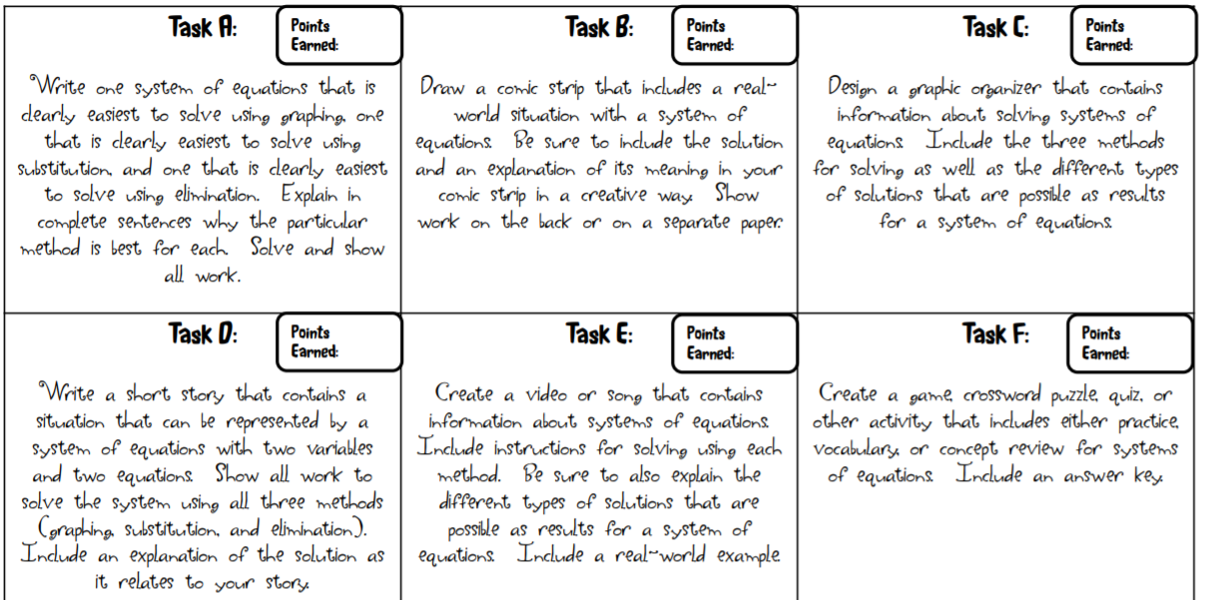
Choose two of the tasks below to complete. Each task is worth 25 points for a total of 50 points.

