RSCS Name:_________________
Class:______________ Date:______________
Cal Tech Homework 11/30
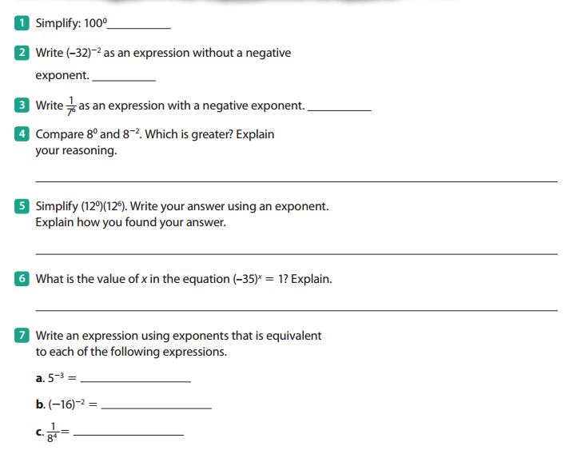
8) ${(2}^{4}×{3^{4})}^{-2}=$

9) $\frac{1}{6^{-5}}=$

